

|  |
| --- |
| Computer Generated Imagery  CGI Case StudyHow does CGI affect the modern world?In today’s world CGI has immense number of applications in almost every field including movies, animation, television programs, printed media and the list never ends.What is CGI? At the most basic level, Computer-Generated Imagery (CGI) is the creation of still or animated visual content with computer software. CGI **most commonly** refers to the 3D computer graphics used to create characters, scenes and special effects in films, television and games. The technology is also used in everything from advertising, architecture, engineering, virtual reality and even art. |
| Page 1 |

|  |  |  |
| --- | --- | --- |
| **CGI**  **The boon to graphics** | | CGI is used extensively these days because it is often cheaper than physical methods which rely on creating elaborate miniatures, hiring extras for crowd scenes, and most commonly for when it's simply not safe or humanly possible to create the visuals. |
| 04 01**HISTORY**02**Roles of CGI**03jujutsu kaisen**CGI AND MOVIES** | **History**For those who want a chronological list you can read thetimeline of CGI in film and television. For the rest of you,I've pulled out what I believe are the most notable milestones that contributed to the evolution of CGI.The history of CGI goes back to the 1950’s, when mechanical computers were repurposed to create patterns ontoanimation cells which were then incorporated into a featurefilm.That first film which used CGI was Alfred Hitchcock’s Vertigo (1958). A few years later CGI took another leap forward with the  help of Hollywood. In 1973 Westworld flexed its muscles  with the first 2D CGI scene showing "Gunslinger" vision - an interpretation of how robots could see. The movie was so successful that it inspired a sequel. | |
|  | | |
| Page 2 **Roles of CGI**The process of creating CGI is long, challenging and very technical. Teams are large and very diverse which means there are opportunities for all types of people ranging from hardcore coders through to illustrators and non-artists who like managing teams. Everyone plays a crucial role in producing the final visual effects and I've listed some of the most common creative and technical roles below to help you understand where you mind fit it best. | | |
|  | | |

## **CGI and movies**

Cinema has evolved greatly since its inception, especially in the area of visual effects (VFX).

In the last few decades, computer generated imagery (CGI) has dominated many movies,

from dramas to animated films and major blockbusters. While revolutionary,

the use of CGI effects has come under much scrutiny in recent years. But what is CGI and

where did its bad reputation come from?

Let’s look at how filmmakers and animators have been secretly injecting your

favorite movies without you even noticing

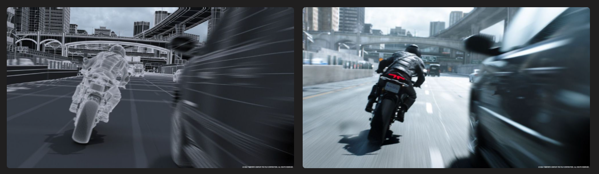  
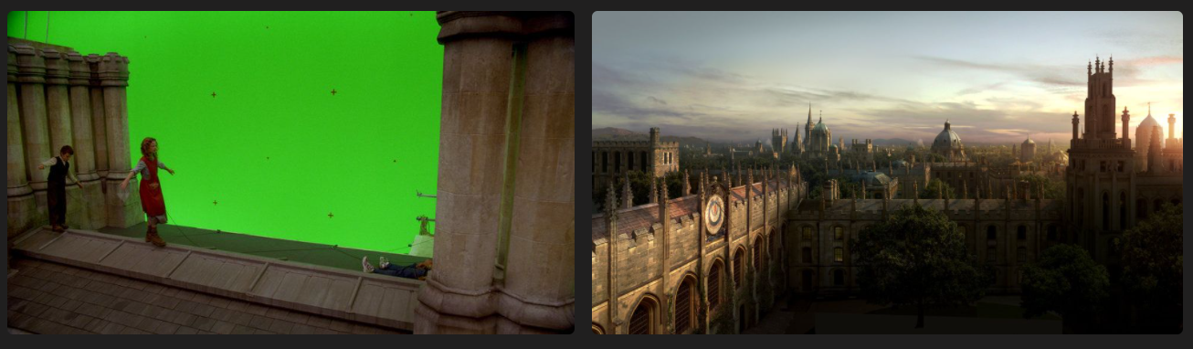

## **VFX breakdown in “Inception” the movie**

## (Click to play the video)

[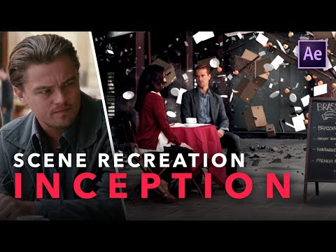](https://www.youtube.com/embed/AzIEWKGm3uM?feature=oembed)

## **Avengers: Endgame | VFX Break down**

[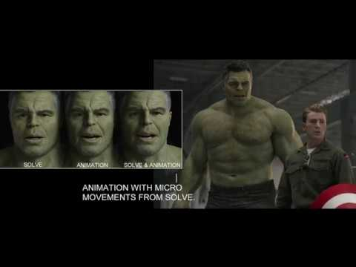](https://www.youtube.com/embed/UzT_SXG_bAI?feature=oembed)

As conclusion, CGI is the symbol of future in film industry CGI started with animation as simple as deformation and reformation but has come to the point where feature length films rely on CGI to make the dreams and stories of director into reality.

# **Advantages:**

1. The impact and details of generated picture is increasing day by day due to fast development in technology.
2. The product images can be ready even before the model comes through the assembly line. This gives more time for marketing.
3. CGI is a versatile technology that can be used to deliver content across multiple media platforms like photography, animated walkarounds, video, AR, VR, etc.
4. The generated images can be directly involved in improving your brand credibility, since it provides your customers and prospects with the best visual experience.
5. Eliminates need for excessive and time-consuming green screen filming and set construction.
6. The director can choose any angle for a scene, including angles that would have been hard or impossible in a live action movie.
7. Light, colours and filters are added digitally after filming.
8. Limitless possibilities for rotating effect.
9. Costumes, make-up, body size and age can be changed to whatever is needed.

10) Characters blend in seamlessly with their digital environments.

**Disadvantages**:

1. Expensive hardware and special programs are required to obtain and process the data.
2. Highly skilled technical animators required.
3. The technology becomes obsolete rapidly as better software techniques are developed.
4. Movement that does not follow the laws of physics generally cannot be represented.